State of Michigan

OBRA Automation suite

Workflows 6 and 7

On Demand Print Determination Letters and Evaluation Search

**Workflows with screenshots:**

Step 1:

OBRA Staff User logs in. Click on Evaluations Module

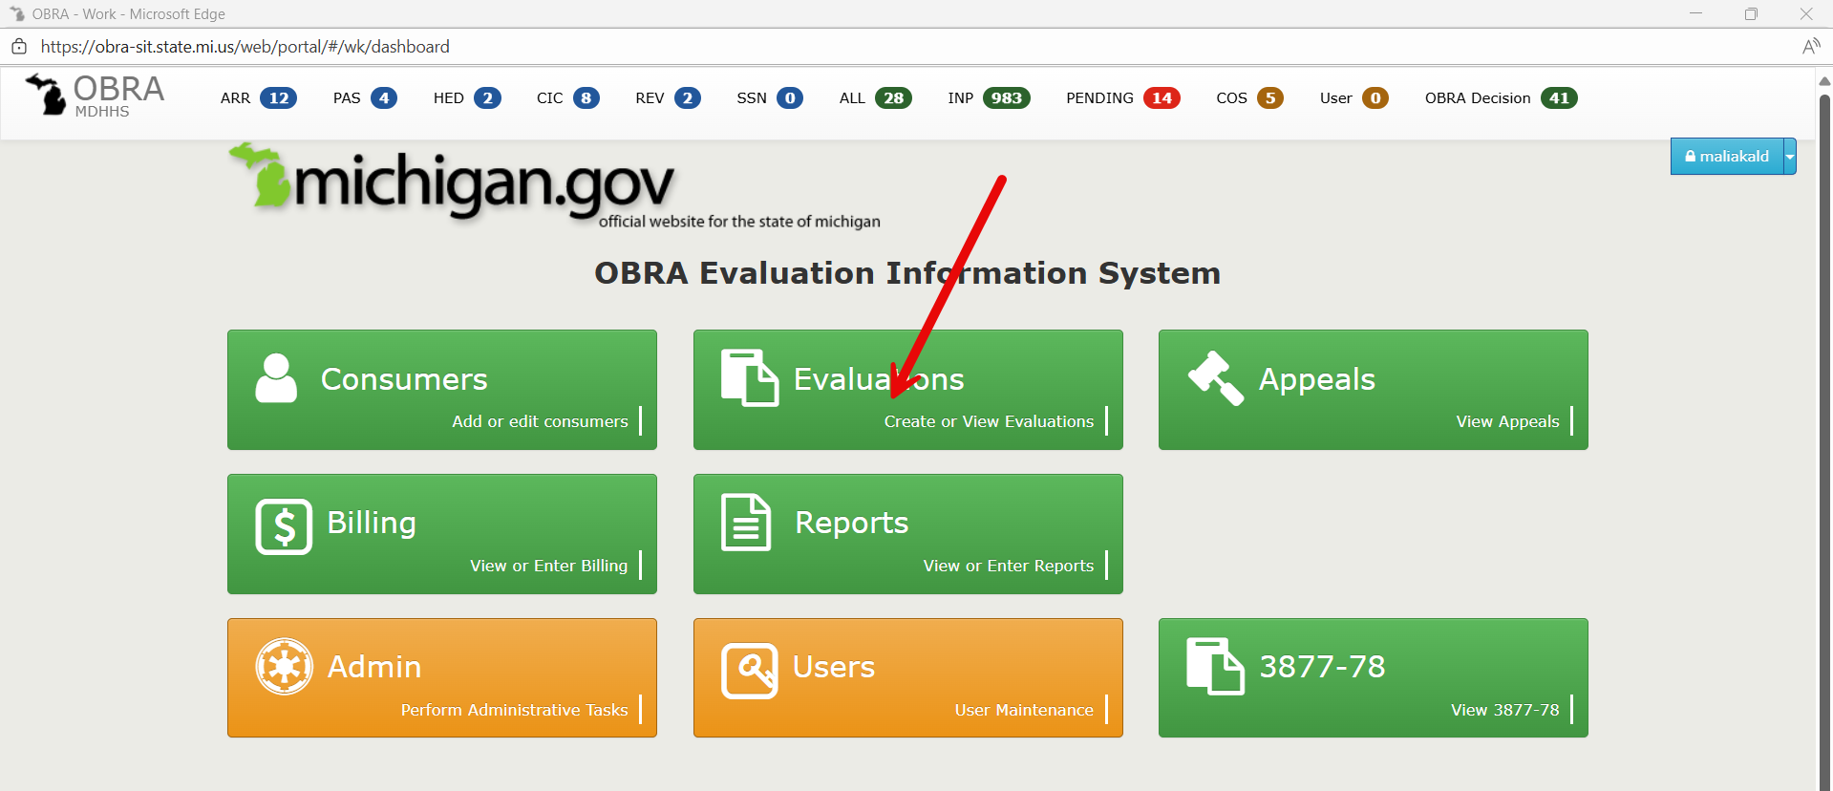

Step 2:

Search for a consumer : Use the search criteria below.

Determination : Nursing facility – No Mental Health Services, Determination date > 01/01/2021

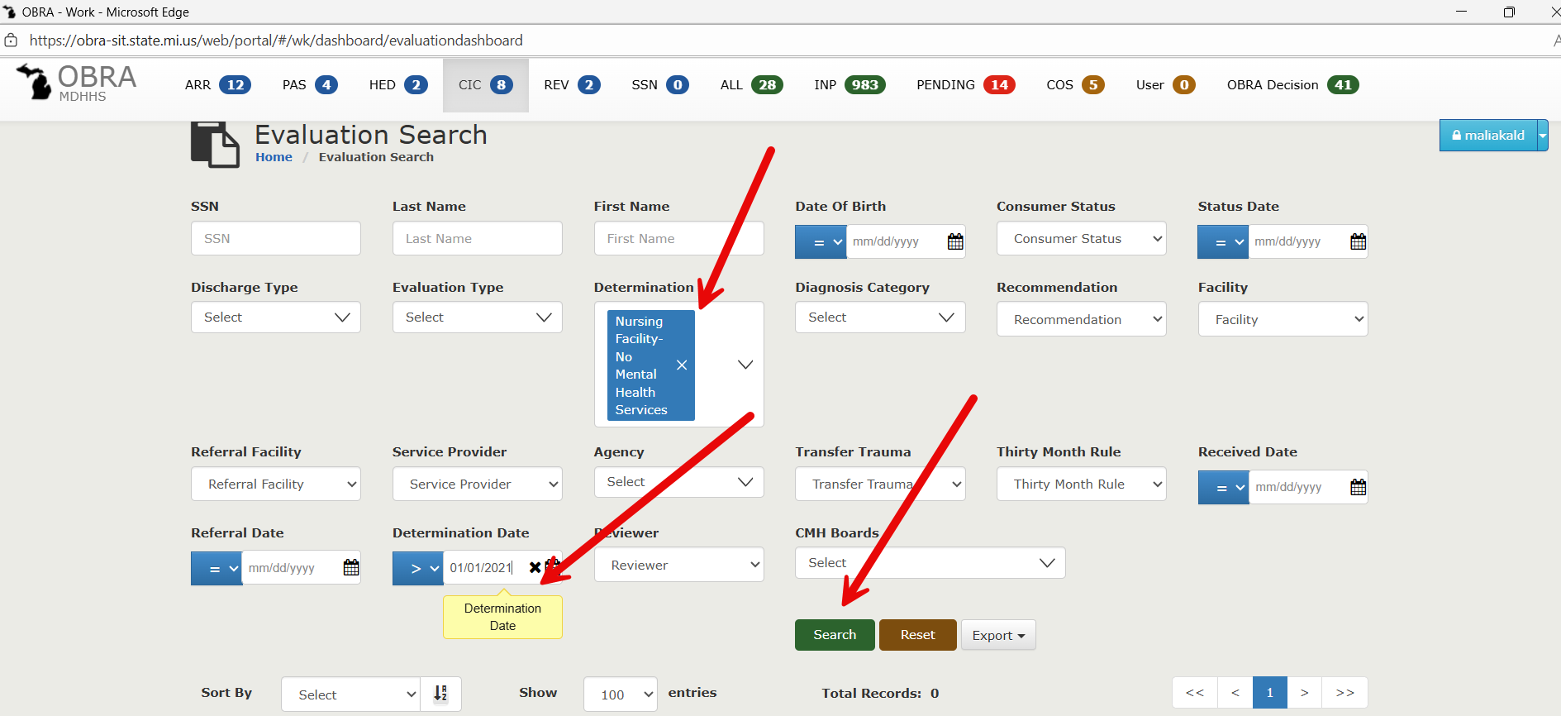

Step 3:  
Results displayed below. Sort by descending order of Determination date. Click on the first record anywhere on that row.

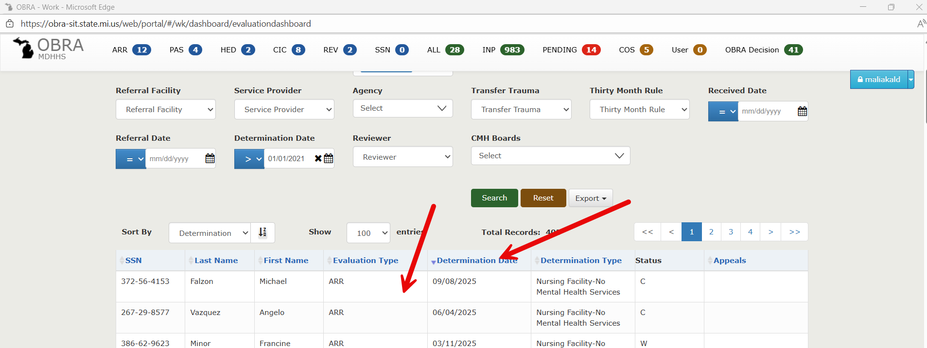

Step 4:

Land on Evaluation Detail Completed page. Click on the drop down menu next to the Consumer Name.

Step 5:

Pop window opens.Click OK.

Step 6:

Letter opens up in new window. Capture the PDF.

Step 7:

Go back to Evaluation detail completed screen. Click on “Evaluations” on the breadcrumb

Step 8:

Change the determination to “Nursing Facility – Specialized Mental Health Services” by following the steps below.

Step 9:  
Results displayed below. Sort by descending order of Determination date. Click on the first record anywhere on that row.

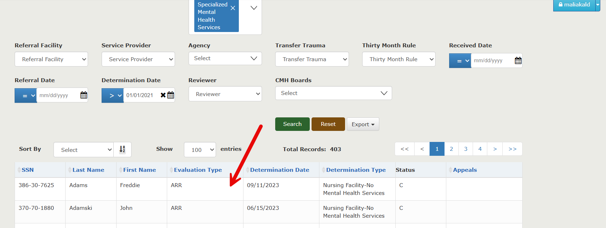

Step 10:

Land on Evaluation Detail Completed page. Click on the drop down menu next to the Consumer Name.

Step 11:

Pop window opens.Click OK.

Step 12:

Letter opens up in new window. Capture the PDF.

Step 13:

Go back to Evaluation detail completed screen. Click on “Evaluations” on the breadcrumb

Step 14:

Change the determination to “Nursing Facility – Other Mental Health Services” by following the steps below.

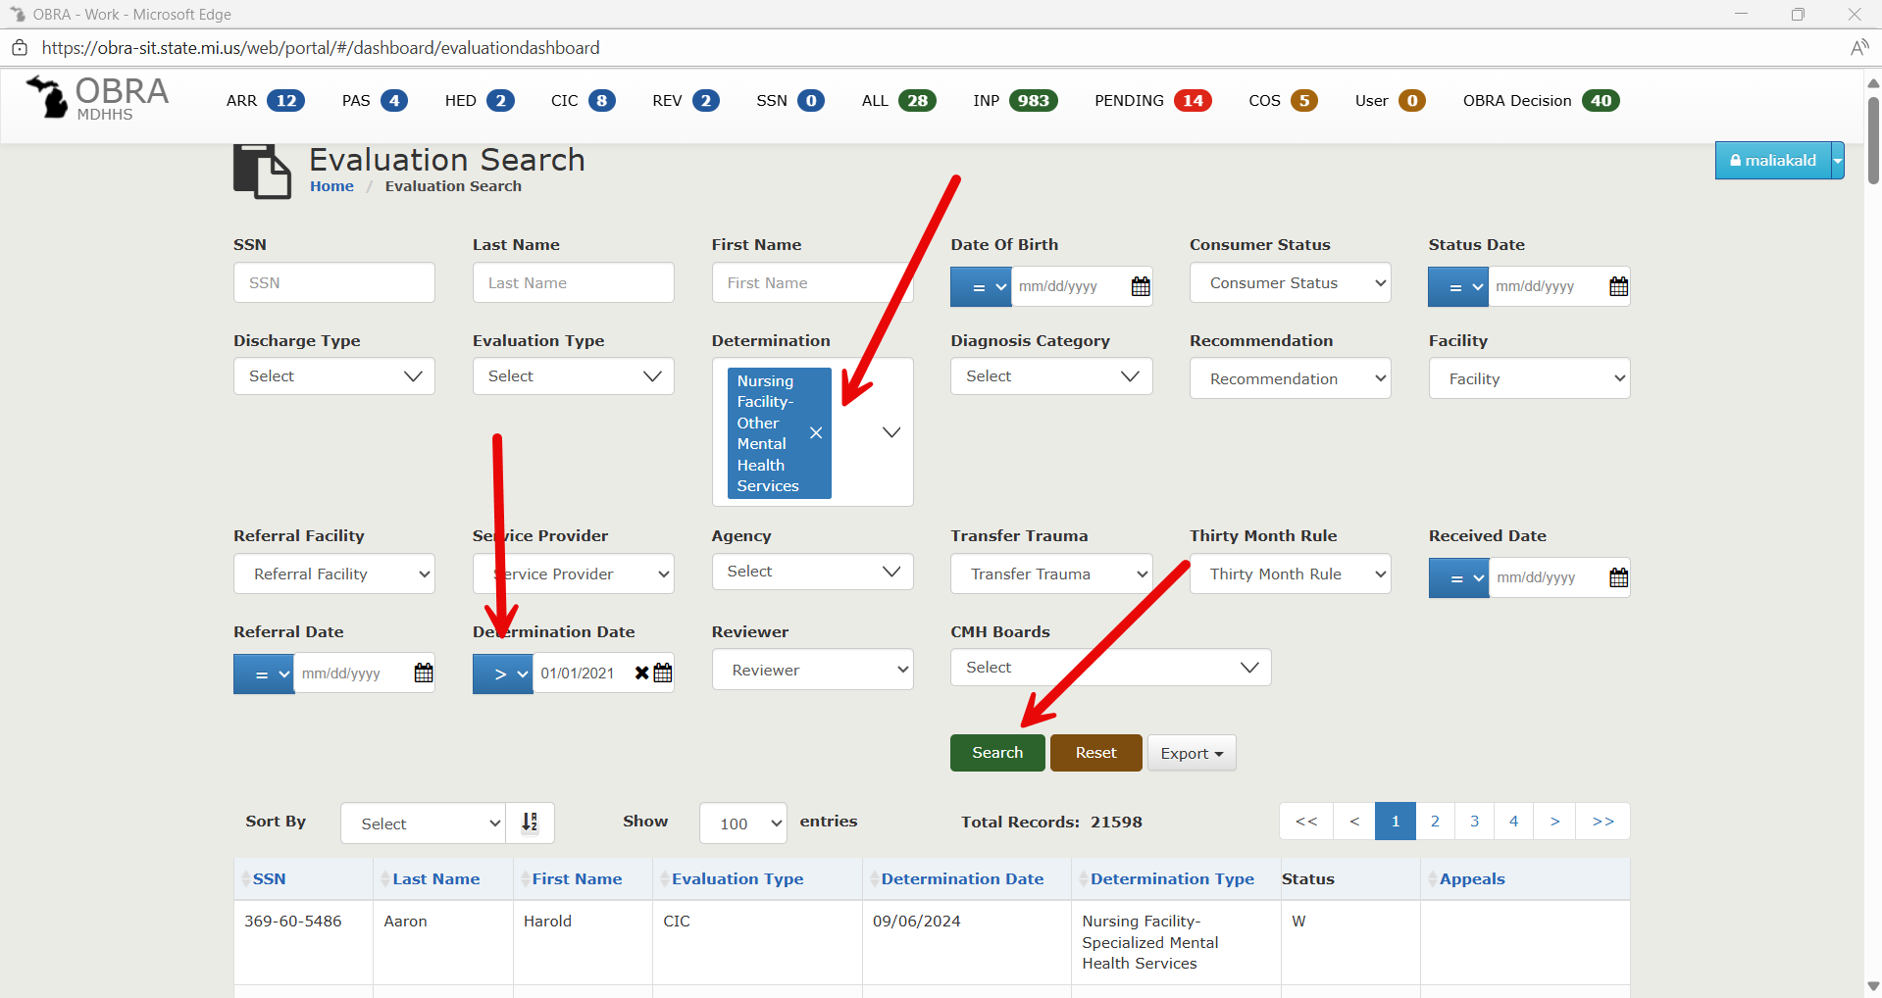

Step 15:  
Results displayed below. Sort by descending order of Determination date. Click on the first record anywhere on that row.

Step 16:

Land on Evaluation Detail Completed page. Click on the drop down menu next to the Consumer Name.

Step 17:

Pop window opens.Click OK.

Step 18:

Letter opens up in new window. Capture the PDF.

Step 19:

Go back to Evaluation detail completed screen. Click on “Evaluations” on the breadcrumb

Step 20:

Change the determination to “No Nursing Facility – Specialized Mental Health Services” by following the steps below.

Step 21:  
Results displayed below. Sort by descending order of Determination date. Click on the first record anywhere on that row.

Step 22:

Land on Evaluation Detail Completed page. Click on the drop down menu next to the Consumer Name.

Step 23:

Pop window opens.Click OK.

Step 24:

Letter opens up in new window. Capture the PDF.